Worksheet 2
Vyřešené pracovní listy mi prosím pošlete na e-mail: k.kubelkova@zspetriny.cz
- Revise colours and numbers from 0-20 (Zopakuj si barvy a čísla od 0-20)
  - Colours
    - https://learningapps.org/display?v=pamj7ppqk20
    - https://learningapps.org/display?v=p26fsbk3k20
  - Numbers
    - https://learningapps.org/display?v=phebnq6sn20
    - https://learningapps.org/display?v=pg588n4a320
- Watch this video and answer the questions below (Zhlédni toto video a odpověz na zadané úkoly)
  - https://www.youtube.com/watch?v=nxllySllKbE&t=621s
  - Questions
    - Match (spoj)
5-12 hour Good evening
12-18 hour Good morning
18-20 hour Good night
20-5 hour Good afternoon

    - Finish the sentences (dokonči věty)
The king is strong.
Princess Sylvia is………………………………..
Colvex is……………………………………………
Bob is……………………………………………….
Muzzy is……………………………………………
    - Who has got a motorbike?
    - Princess Sylvia: “I´ve got a bag. I´ve got a…………………………….. I´ve got a …………………………………”
    - Which fruits are in the garden?
- Describe this picture in 5-10 sentences (use there is, there are)/ Popiš obrázek v 5 – 10 větách (použij There is/There are)
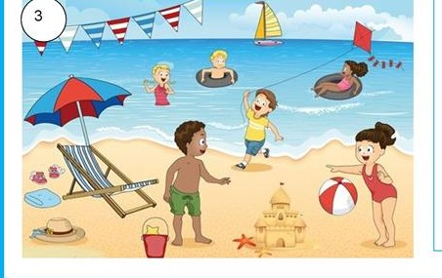

There is a ball.
There are three shells.

