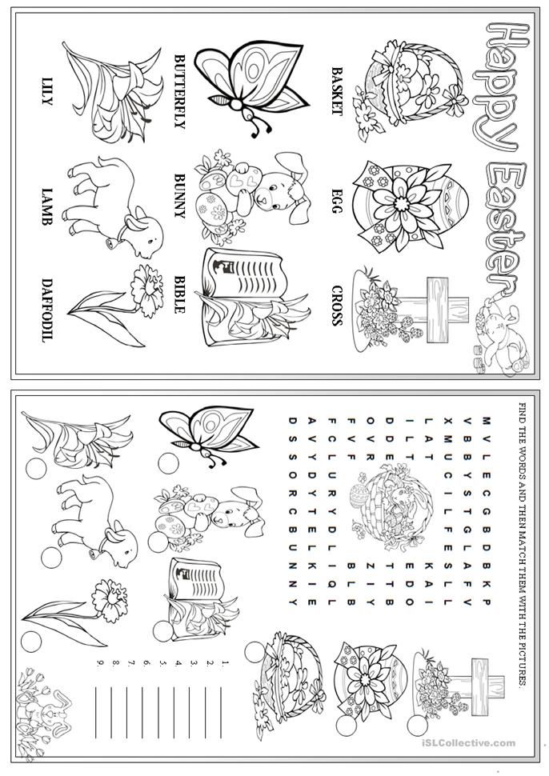

Read the short text about Easter in England. Answer the questions below. (Přečti si text o Velikonocích v Anglii. Pak odpověz na otázky)
Easter is always on a Sunday between March and April. On Easter morning British children play a very special treasure hunt called “Treasure Hunt Eggs”. The parents hide decorated eggs in their gardens and the children have to find them. The winner is the boy or the girl who find the largest number of eggs.

- How do children get the decorated eggs in England?
- Where do parents hide the decorated eggs?
- What is the name of the game children play on Easter?
- Who is the winner of the game?
- Which day is Easter celebrated in England? + Is it a different day in the Czech Republic?

Look at these prepositions of place. Do you know what they mean? (Podívej se na předložky místa. Víš, co znamenají?
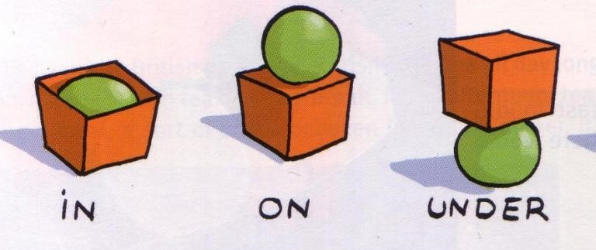

Now look at the picture and fill the sentences with in/on/under (Podívej se na obrázek a doplň věty za použití in/on/under)
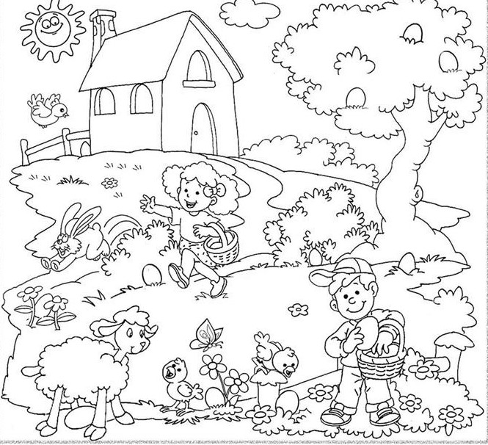
There is an egg _________ the bush. It´s orange.
There are three eggs _________ the tree. They are yellow, blue and pink.
There is an egg __________ the lamb. It´s green.
There is an egg __________the flowers. It´ s red.
There is an egg __________ the girl´ s basket. It´s black.

Answer these questions (Odpověz na otázky)
How many eggs can you find in the picture?
How many flowers are there?
Is there a bunny?
How many children are there?
How many eggs are in the boy´s basket?

