Week 4.-7.5.
- Choose and write (Vyber a napiš)
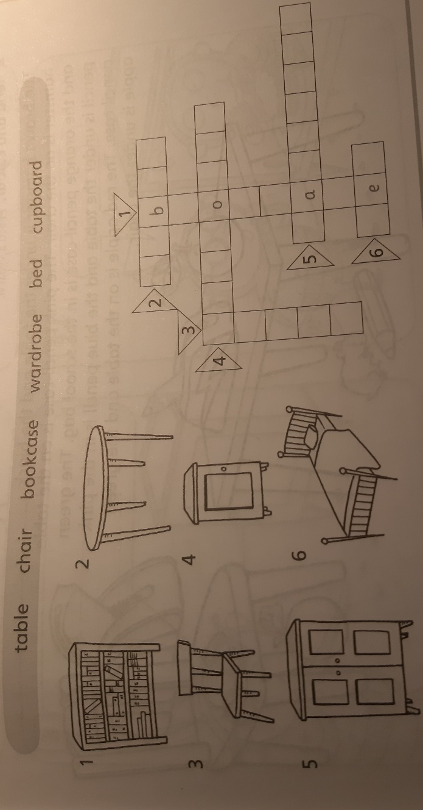

- Read and match (Přečti a přiřaď)
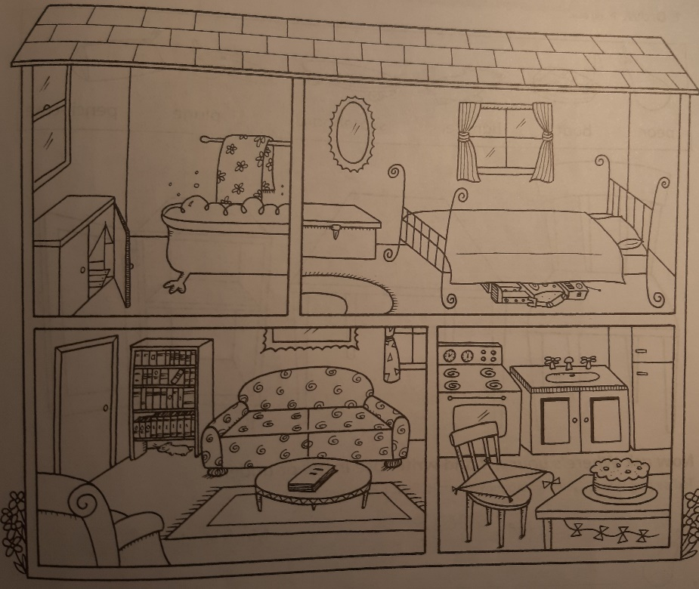
  - Where´s the cake? 1. It´s on the chair, in the kitchen.
  - Where ´s the hamster? 2. It´s on the table, in the sitting room.
  - Where´s the boat? 3. It´s under the bed, in the bedroom.
  - Where´s the book? 4. It´s under the bookcase, in the sitting
room.
  - Where´s the robot? 5. It´s on the table, in the kitchen.
  - Where´s the kite? 6. It´s in the cupboard, in the bathroom.

- Answer the questions (Odpověz na otázky)
  - How many chairs have you got at home? – I´ve got………chairs at home.
  - How many tables have you got at home? – I´ve got………………………………………
  - How many beds have you got at home? – I ´ve……………………………………………..
  - How many wardrobes have you got at home? – I…………………………………………
  - How many cupboards have you got at home? - ……………………………………………

- Watch the video about Muzzy and answer the questions (Podívej se na video o Muzzym a odpověz na otázky)

https://www.youtube.com/watch?v=HrWHEXeElNY

  - How old is Bob?
  - What is the number of Bob´s cell?
  - What does Muzzy like to eat?
  - What does not Muzzy like to eat?
  - Draw picture of commands: Go away! and Come here!

