Week 18.-22.5.
- New vocabulary (nova slovíčka)
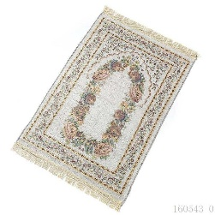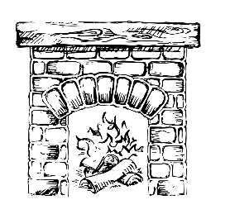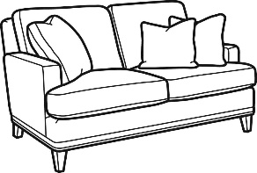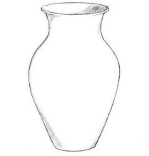
a rug a fireplace a sofa a vase a painting

- Where can you find….in a house? (Kde v dome můžeš najít…..?)
Where can you find a rug in a house? - In a bedroom.
Where can you find a fireplace in a house? In a………………………………………….
Where can you find a sofa in a house? In a………………………………………….
Where can you find a vase in a house? In a………………………………………….
Where can you find a painting in a house? In a………………………………………….

- Where is…..? On/in/under (Kde je…? Na/v/pod)
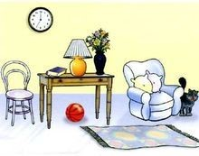
- The clock is ………….. the wall.
- The ball is …………….. the table.
- The carpet is ………… the floor.
- The lamp is …………… the table.
- The flowers are………. The vase.

- Game
Write as many words as you can from each category. You have got 2 minutes for each category (Napiš co nejvíce slov z každé kategorie. Na každou kategorii máš 2 minuty).
Categories:
- Toys
- Colours
- Food and drinks
- Numbers
- School supplies (školní potřeby)
- Animals
- At home (domov)

- Listen to the song
In the Muzzy video, Bob writes and says English alphabet. Listen to this song and remember it. (V Muzzym Bob představil anglickou abecedu. Poslechni si tuhle písničku a připomeň si ji).

https://www.youtube.com/watch?v=75p-N9YKqNo

